Kuali Aggregator Guide for

FY25 Internal Funding Programs

Internal Funding Programs

UMass Boston currently has three Grant Programs accepting Internal Applications.
Internal Submission are due April 1, 2024 at 5pm EST.

- Public Service Grant Program
- Joseph P. Healey Research Grant Program
- Proposal Development Grant Program

Creating an Internal Grant Proposal in Kuali PD

Applicants are required to submit Proposals through Kuali Proposal Development (PD). Applicants must contact their Department’s Research Administrator for assistance in submitting their application.

Follow the guidelines below to correctly fill out PD for and Internal Submission. Please reference the full guide here, for further information.

Create Proposal Screen

Fill out the Create Proposal Screen, accordingly -

Create Proposal Screen
Proposal Type | Internal UMass
Lead Unit | Choose PI’s Unit
Activity Type | Choose Relevant Activity Type
Project Dates | 07/01/2024– 12/31/2025
Sponsor | University of Massachusetts Boston – 0000003351
Principal Investigator | Select PI
Sponsor Deadline | 4/1/2024
Sponsor Deadline Type | Internal / No Submission

Basics Section

In the Basics section, you do not need to update the following sections: Proposal Details Tab or Organizations & Locations Tab. Only the Delivery Info Tab and the Sponsor Program & Info Tab need to be updated.

Delivery Info Tab
Submission Description | Indicate if this Proposal is currently under consideration by another funding source, or if the PI plans to submit to another funding source OR use Other Support Form
Sponsor Program & Info Tab
Notice of Opportunity | Internal UMass
NSF Code | Choose Relevant Code
Anticipated Award Type | Internal Grant

Key Personnel Section

In the Key Personnel section, add any additional Co-PI’s or Key Personnel. If there are multiple PIs/Co-PIs, just the Lead PI will have 100 credit to their name section. Co-PI(s) and other Personnel will leave theirs at 0. For all personnel, their Unit must have 100 and 100 listed.

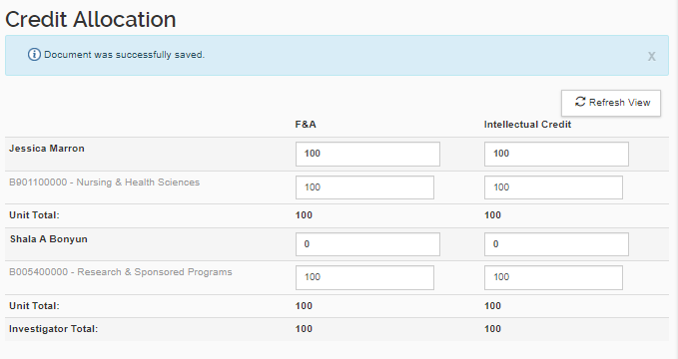

Questionnaire Section

Complete this section as described in Kuali Proposal Development Aggregator Guide found here.

Compliance Sections

Complete this section as described in Kuali Proposal Development Aggregator Guide found here.

Attachments Section

Excluding the ORSP Budget Workbook, the following attachments must be completed and saved as a PDF for your Internal Submission.

Attachment Checklist
Attachment Tab | Attachment Type | Document
Proposal | Budget Justification | Budget Justification
Proposal | Project Summary | Abstract
Proposal | Narrative | Project Narrative
Proposal | Supplementary Documentation | Letters of Collaboration (if applicable)
Personnel | Biosketch | Biosketch(es)
Personnel | Current Pending | Current and Pending Support
Internal | ORSP Budget Workbook | ORSP Budget Workbook (xls)

Supplemental Information Section

If there are multiple PI/Co-PIs, you must complete the PI and co- PI Responsibilities tab as described in Kuali Proposal Development Aggregator Guide found here.

