READ FIRST!
The following instructions are only for external/non-UMB individuals who need access to the UMass Boston CITI trainings but do not have a UMass Boston email account.
Individuals who have a UMass Boston email account need to log in through our University of Massachusetts single sign-on (SSO) link at: https://www.umb.edu/orsp/research_committees/irb/required_training

New to CITI? Access the website here: https://www.citiprogram.org
If you do not have a UMass Boston email account, select “REGISTER” if you have never used CITI before.
- If you do not have a UMass Boston email account, do not use the “LOG IN THROUGH MY ORGANIZATION” option.

Follow the steps in CITI.

Step 1: Select Your Organization Affiliation
- Type out “University of Massachusetts Boston” in the search box. Do not abbreviate. Do not select “University of Massachusetts Boston (SSO)” as the SSO is only available to individuals with a UMass Boston email account.
- Confirm “I agree” to terms and service and “I affirm that I am an affiliate of University of Massachusetts Boston.”
- Agree to the two boxes and “Continue to create your CITI program username/password.”
- Do not use the “Independent Learner Registration” option. If you are asked to pay, you have selected the wrong option. CITI training is at no cost to you.

Step 2: Personal Information (name and email address).
- Use your preferred email address. CITI sends reminder notices or password resets to this email.
Step 3: Create your username and password
Step 4: Country of Residence
Step 5: Continuing Education Unit (CEU) – select NO unless you plan to purchase CEUs
Step 6: Complete registration questions. Since you do not have a UMB email, you may enter your preferred email.
Step 7: Enable the software by selecting the appropriate coursework
- Several courses are available in CITI for your needs. You can take any UMB courses available in CITI.
- To access the specific training required for Human Subjects Research, you must select “Yes, I conduct research with live human beings, human samples or with data derived from human beings.”
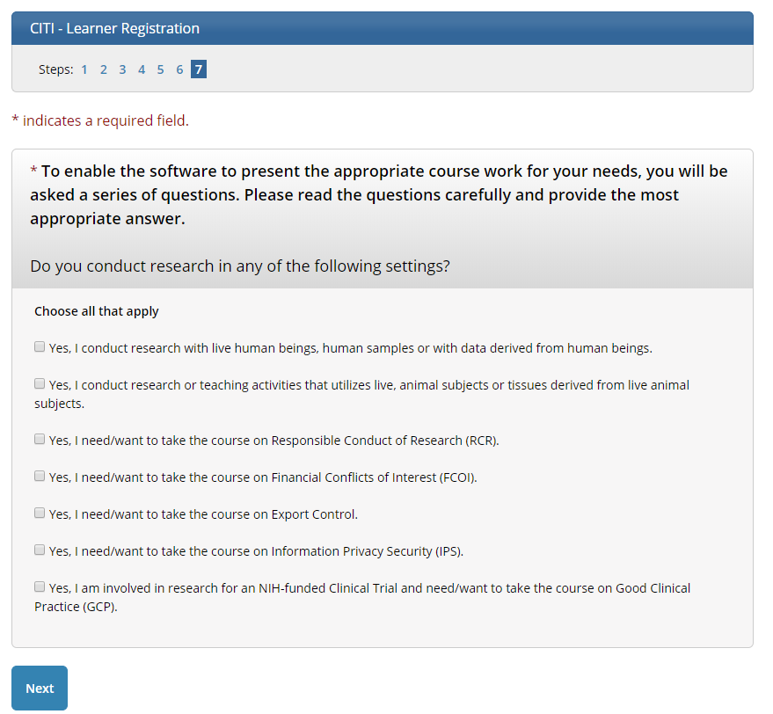
- For Human Subjects Research, select the group that best corresponds to your research and/or interests: “Social & Behavioral Research” or “Biomedical Research.” You are not required to take both. (“IRB Members” is an option for members and staff of the UMB IRB.)

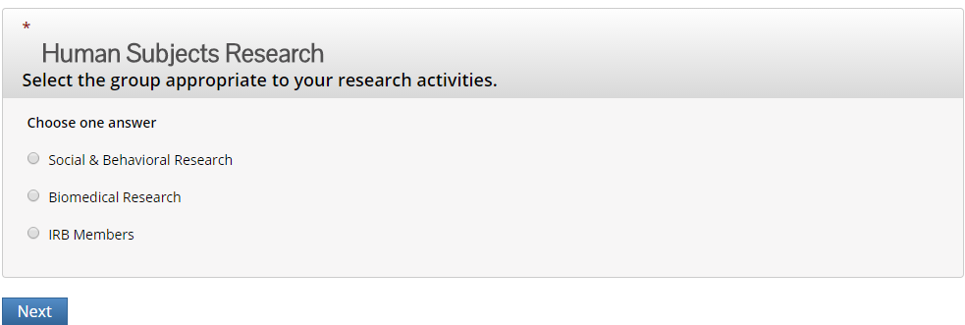

- Next, select “Finalize Registration”
- To access your courses (under My Courses), select “University of Massachusetts Boston Courses.”

Please note: you will need to select “Complete the Integrity Assurance Statement before beginning the course.” Review the Terms of Service and check the box to accept, then select the submit button.
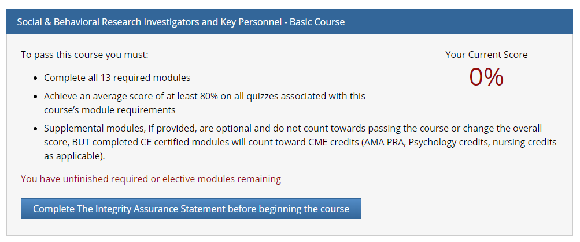
You will now be able to access the training modules. Follow the onscreen prompts to navigate within the course. The CITI program will save your progress should you choose to exit and complete the modules in multiple sessions.

