CITI FCOI Training

Under “Create an account” select “Register” (Do not use the “Login via SSO” option)

Step 1: Select Your Organization Affiliation (enter University of Massachusetts Boston into search box)
Step 2: Personal Information (name and email address)
Step 3: Create your username and password
Step 4: Country of Residence
Step 5: Continuing Education Unit (CEU) – select NO unless you plan to purchase CEUs. More info on CEUs here: https://www.citiprogram.org/index.cfm?pageID=248
Step 6: Complete registration questions
Step 7: Enable the software by selecting the appropriate coursework

To complete the training necessary for Financial Conflicts of Interest (FCOI) select the following:
Select Add a Course or Update Learner Groups
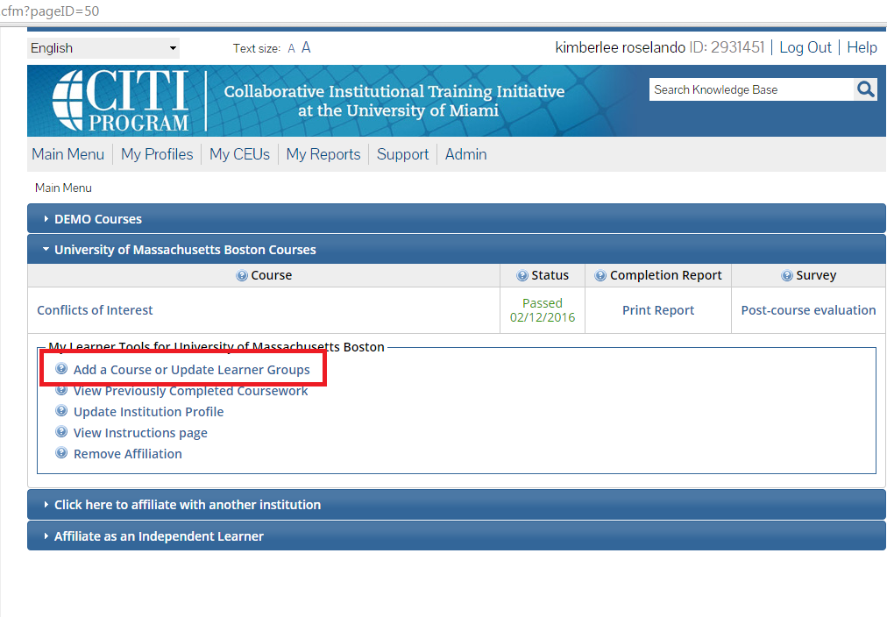Check the 4th option “Yes, I need/want to take the course on Financial Conflicts of Interest (FCOI)”
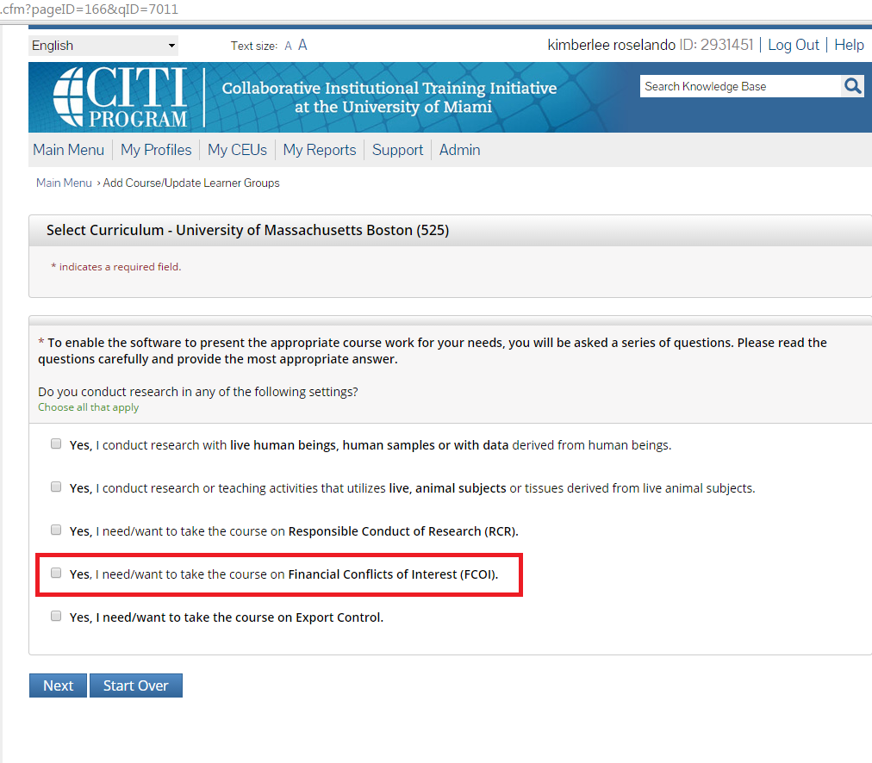

Next, select “Finalize Registration”
Under “University of Massachusetts Boston Courses” select the course name hyperlink and a new page will open
Please note: you will need to select “Complete the Integrity Assurance Statement before beginning the course.” Review the Terms of Service and check the box to accept, then select the submit button.
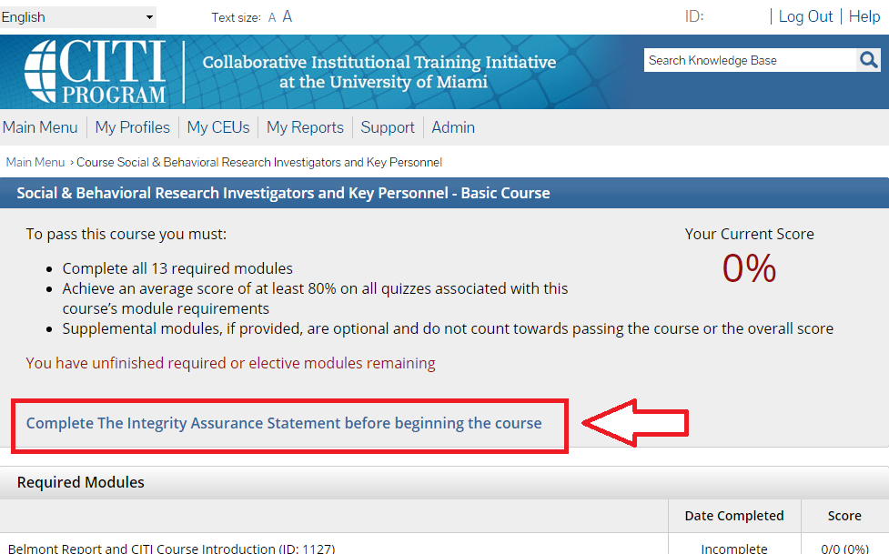

You will now be able to access the training modules. The CITI program will save your progress should you choose to complete the modules in multiple sessions.

