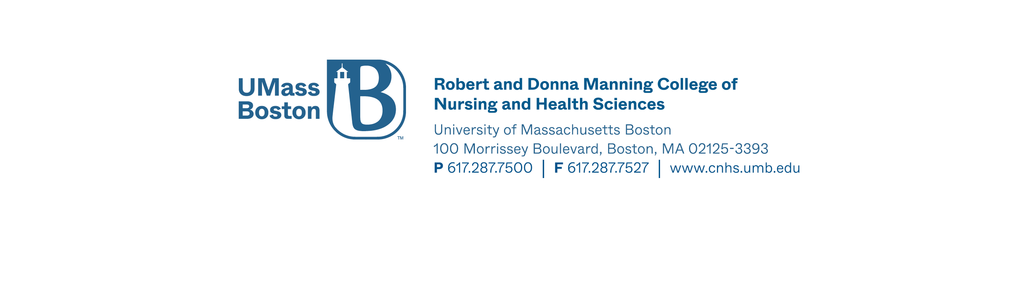

Accelerated Nursing Option Supplemental Form

Last Name: ____________________First Name: _____________________ UMS #: _______________(if available)

Phone _____________________________ Email: _____________________________

Optional: Age: ________ DOB: _________________ Gender: Female Male

Ethnicity: ___________________________________________
Alaska Native – American Indian – Asian – Black or African American – Hispanic/Latino – Native Hawaiian – Other Pacific Islander – White (not of Hispanic origin) – Other (please specify)

Please fill out this lower half of the form completely. If a course is in progress, please indicate “IP” under “Grade” column. All entries will be cross checked against submitted official transcripts; please be sure all entries are correct. Submit this form as part of your application package.
Prerequisite Courses | Course # | Course Title | Credits | School Name | Term/ Year | Grade | Repeated course Y/N
*Human Anatomy I and Physiology with lab
*Human Anatomy II and Physiology with lab
*Microbiology with lab
Statistics
Growth and Development (through the lifespan)
Human Nutrition
Social Science Elective (Introduction to Psychology or Intro to Sociology

Applicants must have all prerequisite courses completed by the application deadline. All prerequisite courses must be completed with official documentation submitted along with your application packet.

*Please note the 4 credit prerequisite courses Anatomy and Physiology I, Anatomy and Physiology II and Microbiology (with lab) must be taken within 10 years of application and must receive a grade of C+ or higher and all prerequisite courses must be satisfactorily completed prior to matriculation.
____________________________________________________________________________________________________________

List All Colleges Ever Attended (Graduate and Undergraduate) | Dates Attended | Degree Earned | Date Degree Awarded

Student Signature: ___________________________________________ Date: ____________

